What is Carbon Management?

Introduction

Carbon management is a growing field for addressing the contribution businesses have to climate change and reducing greenhouse gas emissions. This article will explore what carbon management is, evidence-based explanations as to why carbon measuring and reporting is important, and how your organization can employ effective carbon management strategies.

What is carbon management

Carbon management is an organized approach to gain the strategic advantages of CO₂ emissions reductions. According to the World Resources Institute(WRI), effective carbon management, including systematic measurement and monitoring – can help to avoid and reduce greenhouse gas emissions across an organization's value chain and business operations.

With mandatory reporting requirements in the UK and EU, and stakeholder pressure for businesses to set goals to reduce emissions and implement carbon management helps businesses, measure, track, and manage emissions in an organized way.

Carbon emission 2023

“Here are the level of carbon emission in 2023 for top 4 countries.” 

|  |  |  |
| --- | --- | --- |
| Rank | Country | CO₂ Emissions (2023) |
| 1 | **China** | ~12.6 Gt CO₂ equivalent |
| 2 | **United States** | ~4.7 Gt CO₂ equivalent |
| 3 | **India** | ~2.4 Gt CO₂ equivalent |
| 4 | **Russia** | ~1.8 Gt CO₂ equivalent |

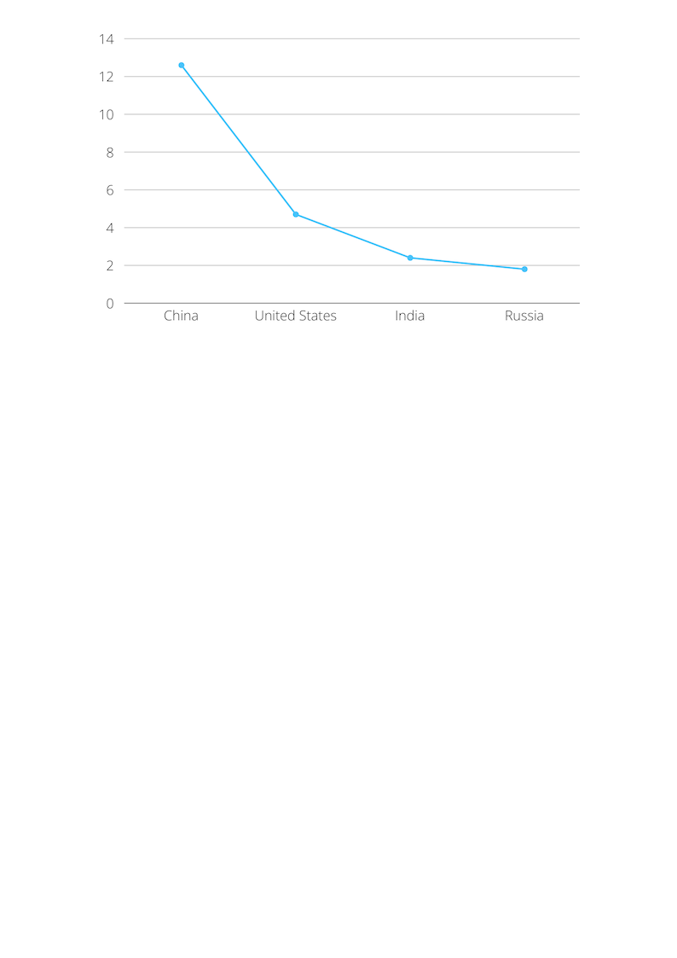

Why it is important?

Carbon management does not just look at the problem of carbon emissions added to the atmosphere each year, it supports the development of technologies and approaches to address the legacy emissions and hard to abate

industrial emissions.

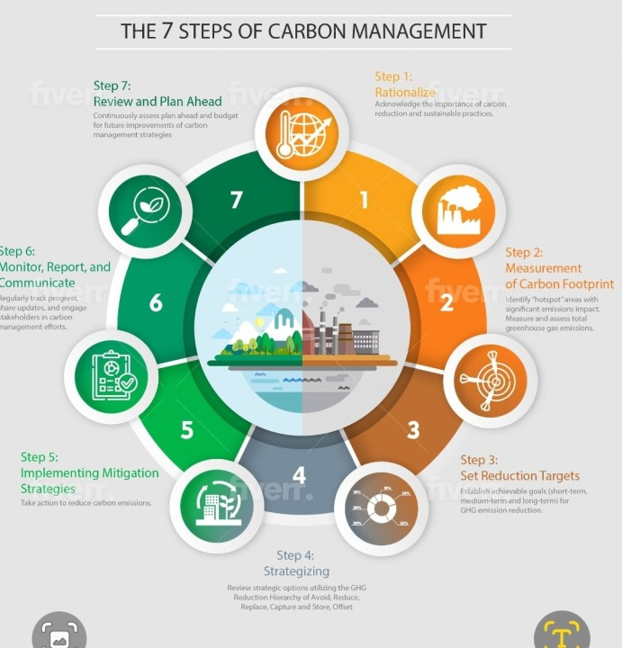

key Benefits

* Reduces greenhouse gas emissions and combats climate change
* Improves energy efficiency and reduces operational costs
* Ensures compliance with environmental regulations
* Enhances brand reputation and public image

Real World Applications

|  |  |
| --- | --- |
| * **Sector** | * **Application** |
| * Corporate Sustainability | * Tech giants (e.g., Google, Microsoft) aim for carbon neutrality |
| * Construction | * Use of low-carbon materials and green building certifications . |
| * Energy | * Wind, solar, hydro projects to replace fossil fuels |
| * Transportation | * Electric vehicles (EVs), carbon offset programs in airlines |
| * Agriculture | * Sustainable practices like no-till farming, composting, and biochar use |

Carbon footprints

A carbon footprint represents the total amount of greenhouse gases, like carbon dioxide and methane, released into the atmosphere by a specific activity, organization, product, or individual. It's a measure of the impact on climate change. Understanding and reducing one's carbon footprint is crucial for mitigating climate change.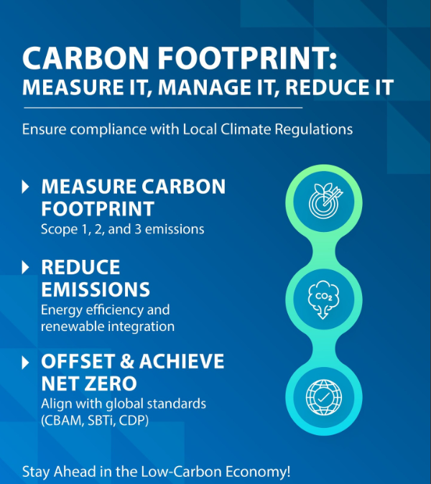

Challenges in carbon management

Carbon management faces several challenges, including high initial implementation costs and a lack of awareness or technical expertise. Inconsistent regulations across countries make standardization difficult. Accurate data tracking is complex, and access to advanced technologies is limited in some regions. Additionally, weak policy enforcement and limited financial incentives hinder broader adoption.

What is carbon accounting

Carbon accounting, also known as greenhouse gas accounting, is the process of measuring, tracking, and reporting an organization's greenhouse gas (GHG) emissions. It provides a framework for quantifying the total amount of carbon dioxide and other GHGs emitted from various activities, both directly and indirectly, within a defined boundary.

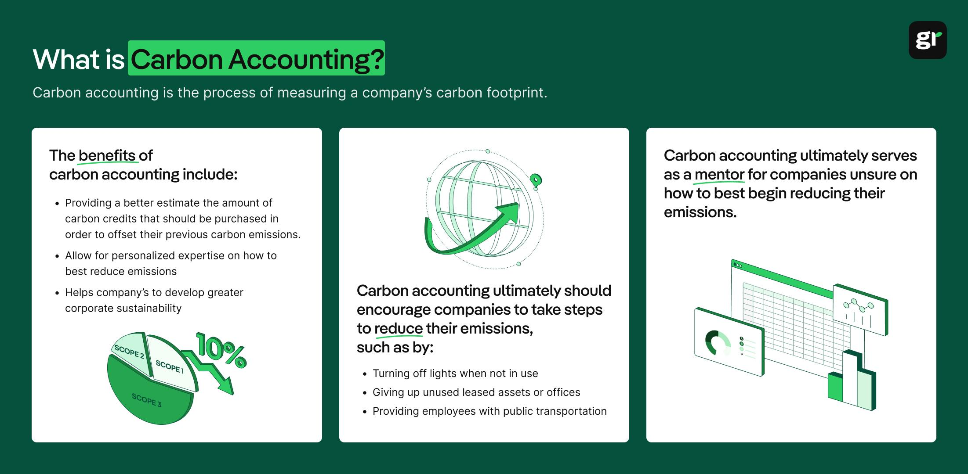

Carbon management in the Gulf

Carbon management in the Gulf region is a growing area of focus, driven by both global climate commitments and the region's own economic diversification goals. The Gulf Cooperation Council (GCC) states are actively pursuing carbon capture and storage (CCS) and carbon capture, utilization, and sequestration (CCUS) technologies to reduce emissions, particularly from the energy sector. Initiatives include developing CCS facilities, promoting CCU projects, and investing in carbon offsetting programs.

Here's a more detailed look at carbon management in the Gulf:

**Key Initiatives and Technologies:**

* **Carbon Capture and Storage (CCS):**

The GCC states have been early adopters of CCS, with significant capture capacity already in operation. Projects like the Ras Laffan Facility in Qatar and the Uthmaniyah CO₂-EOR Project in Saudi Arabia are examples of large-scale CCS implementation.

* **Carbon Capture, Utilization, and Sequestration (CCUS):**

Beyond CCS, the region is also exploring CCUS, which involves using captured carbon dioxide in various industrial processes. The UAE has ambitious CCUS targets, aiming for 5 MTPA of capacity by 2030.

* **Carbon Offsetting:**

The Global Carbon Council (GCC), established in 2019, is a key player in the voluntary carbon market, aiming to develop standards and frameworks for carbon offsetting.

* **Net-Zero Targets:**

Several GCC nations have set net-zero emission targets, with some bringing their targets forward.

* **Hydrogen:**

The use of clean-burning hydrogen is also being expanded as part of the region's efforts to reduce carbon emissions.

Conclusion and Future outlook

In conclusion, carbon management is essential for reducing emissions and promoting sustainable development. While challenges remain, growing awareness and technological advancements are driving positive change. Governments, businesses, and individuals must work together to strengthen carbon strategies. Looking ahead, innovations in clean energy and stricter global policies will play a key role in achieving a low-carbon future.